Pizza Sales SQL Queries

- KPI’s
- Total Revenue:
SELECT SUM(total_price) AS total_revenue
FROM pizza_sales
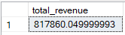
- Average Order Value
SELECT SUM(total_price)/COUNT(DISTINCT(order_id)) AS average_order_value
FROM pizza_sales
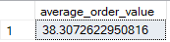
- Total Pizzas Sold
SELECT SUM(quantity) AS total_pizzas_sold
FROM pizza_sales
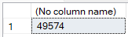
- Total Orders
SELECT COUNT(DISTINCT(order_id)) AS total_orders
FROM pizza_sales
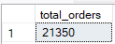
- Average pizzas per order
SELECT CAST(SUM(quantity) AS DECIMAL(10,2))/CAST(COUNT(DISTINCT(order_id)) AS DECIMAL(10,2)) AS average_pizzas_per_order
FROM pizza_sales
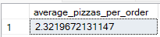

B. Daily Trend for Total Orders:
SELECT DATENAME(WEEKDAY, order_date) AS order_day,
COUNT(DISTINCT order_id) AS total_orders
FROM pizza_sales
GROUP BY DATENAME(WEEKDAY, order_date)
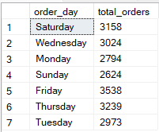
C. Monthly Trend for Total Orders:
SELECT DATENAME(MONTH, order_date) AS month_name,
COUNT(DISTINCT order_id) AS total_orders
FROM pizza_sales
GROUP BY DATENAME(MONTH, order_date)
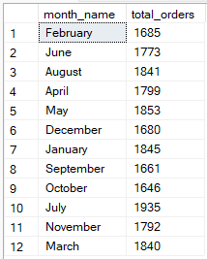
D. Hourly Trend for Total Orders:
SELECT DATEPART(HOUR, order_time) AS order_hour,
COUNT(DISTINCT order_id) AS total_orders
FROM pizza_sales
GROUP BY DATEPART(HOUR, order_time)
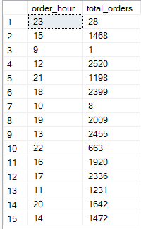
E. Percentage of Sales by Pizza Category:
SELECT pizza_category,
SUM(total_price) AS total_sales,
(SUM(total_price)/(SELECT SUM(total_price) FROM pizza_sales)) * 100 AS PCT
FROM pizza_sales
GROUP BY pizza_category
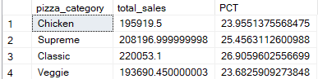
F. Percentage of Sales by Pizza Size:
SELECT pizza_size,
SUM(total_price) AS total_sales,
(SUM(total_price)/(SELECT SUM(total_price) FROM pizza_sales)) * 100 AS PCT
FROM pizza_sales
GROUP BY pizza_size
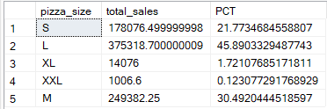

G. Total Pizzas Sold by Pizza Category:
SELECT pizza_category,
SUM(quantity) AS total_sales_quantity
FROM pizza_sales
GROUP BY pizza_category
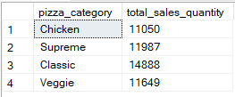
H. Top 5 Best Sellers by Total Quantity
SELECT TOP 5 pizza_name,
SUM(quantity) AS total_sales_quantity
FROM pizza_sales
GROUP BY pizza_name
ORDER BY total_sales_quantity DESC
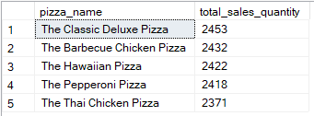
I. Bottom 5 Sellers by Total Quantity
SELECT TOP 5 pizza_name,
SUM(quantity) AS total_sales_quantity
FROM pizza_sales
GROUP BY pizza_name
ORDER BY total_sales_quantity ASC
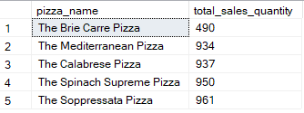
J. Top 5 Best Sellers by Revenue
SELECT TOP 5 pizza_name,
SUM(total_price) AS total_revenue
FROM pizza_sales
GROUP BY pizza_name
ORDER BY total_revenue DESC
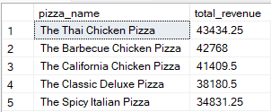
K. Bottom 5 Sellers by Revenue
SELECT TOP 5 pizza_name,
SUM(total_price) AS total_revenue
FROM pizza_sales
GROUP BY pizza_name
ORDER BY total_revenue ASC
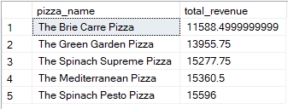
L. Top 5 Best Sellers by Total Orders
SELECT TOP 5 pizza_name,
COUNT(DISTINCT order_id) AS total_orders
FROM pizza_sales
GROUP BY pizza_name
ORDER BY total_orders DESC
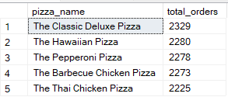

M. Bottom 5 Sellers by Total Orders
SELECT TOP 5 pizza_name,
COUNT(DISTINCT order_id) AS total_orders
FROM pizza_sales
GROUP BY pizza_name
ORDER BY total_orders ASC
